TERMS AND CONDITIONS
Online Only Auction:
Vacant Lot South Lakeview Dr. Shepherdsville, KY 40165
Online Only Auction for Property Located at:
Vacant Lot South Lakeview Dr. Shepherdsville, KY 40165
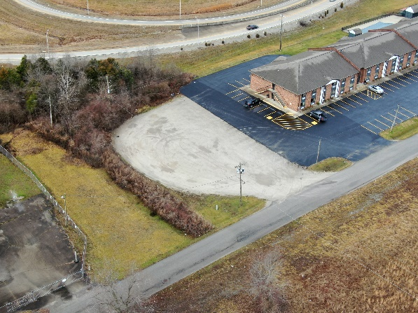
Bidding Details: Bid now at: Bid.Noelauctioneers.com

- Auction Start Date: Sunday, March 24, 2024 at 10:00 AM (EST)
- Auction End Date: Monday, April 1st, 2024 at 7:00 PM (EST)
- Closing date on or before: Thursday, May 16th, 2024 before 5 PM.
- Preview: All showing are made by appointment only. Please contact our Champion Auctioneer and Realtor, Jonathan Noel at email: jonathan@noelauctioneers.com or 859-612-9175
Property Details: Vacant Lot South Lakeview Dr. Shepherdsville, KY 40165
- Type: Commercial Land
- Lot Acres: 0.414 AC
- Area: Bullitt County
- Tax Rate:
- Subdivision:
TERMS: 10% down the day of the auction with the balance due in full within 45 days.
BUYER’S PREMIUM: There will be a 10% buyer’s premium added to the final bid to determine the final sales price.
For additional information, contact Noel Auctioneers and Real Estate Advisors at 859-612-9175 or via email at jonathan@noelauctioneers.com. Visit our website: www.noelauctioneers.com
Jonathan Noel, Owner/Auctioneer.
Please refer to the detailed terms and conditions for further details regarding bidder verification, real estate terms, bidder default, acceptance of bid prices, agency, and more as previously outlined.
Please ensure that all the information provided is accurate and up-to-date. All decisions of Noel Auctioneers and Real Estate Advisors are final. Any dispute between Noel Auctioneers and Real Estate Advisors, its Agents or Representatives and the Buyer(s) will be tried in a court of jurisdiction in Fayette County, Kentucky. By bidding on the property, buyer agrees to all terms and conditions set forth.
AUCTIONEER/BROKER/SELLER DISCLAIMER: The information provided by Noel Auctioneers & Real Estate Advisors is deemed reliable but not guaranteed. This information is given to facilitate the bidding process for prospective buyers, who bear the responsibility of verifying its accuracy and completeness. The property is offered in its 'as-is' condition, with no warranties expressed or implied. All announcements made on the auction day supersede any printed matter.
For additional details, you can contact Noel Auctioneers & Real Estate Advisors at 859-612-9175. Jonathan Noel acts as the Auctioneer for this event.
TERMS: Buyer's Premium: A 10% Buyer’s Premium will be added to the highest bid to determine the final sale price.
AUCTION TIMES: Noel Auctioneers & Real Estate Advisors conduct Live/Online Auctions as timed events, with bidding closing at a specified time. There's an auto extend feature, where if a bid is placed in the final 5 minutes, the auction's closing time is automatically reset to 5 minutes remaining.
SERVER & SOFTWARE TECHNICAL ISSUES: In case of technical issues related to the server, software, or any other online auction-related technologies, Noel Auctioneers & Real Estate Advisors reserve the right to extend or continue the bidding, or close the bidding. In such events, registered bidders will be notified via email.
REAL ESTATE TERMS: A non-refundable earnest money of 10% of the total sale price is required within 24 hours of the close of the auction. The remaining purchase price is due at closing, which will take place within 45 days of close of bidding.
BUYER’S PREMIUM: A buyer’s premium of 10% is added to the bid price to arrive at the final purchase price.
AUCTION BIDDER DEFAULT: If the winning bidder fails to submit the signed Contract for Sale of Real Estate and the 10% earnest money deposit within 24 hours of auction closure, they will be charged a penalty fee of $5,000.00 on the credit card provided at auction registration.
Real Estate Taxes and Closing Cost: All real estate taxes will be prorated for 2024. Purchasers will pay all other closing costs associated with their side of the sale.
Bidder Verification: The identity of all bidders will be verified; if complete verification is not possible, Noel Auctioneers & Real Estate Advisors will reject the registration, and bidding activity will be terminated.
NEW DATA, CORRECTIONS, AND CHANGES: Bidders should check for updated information prior to the scheduled auction time to inspect any changes, corrections, or additions to the property information.
For additional information, contact Noel Auctioneers & Real Estate Advisors at 859-612-9175.

